Press Release for Space Coast HR Association

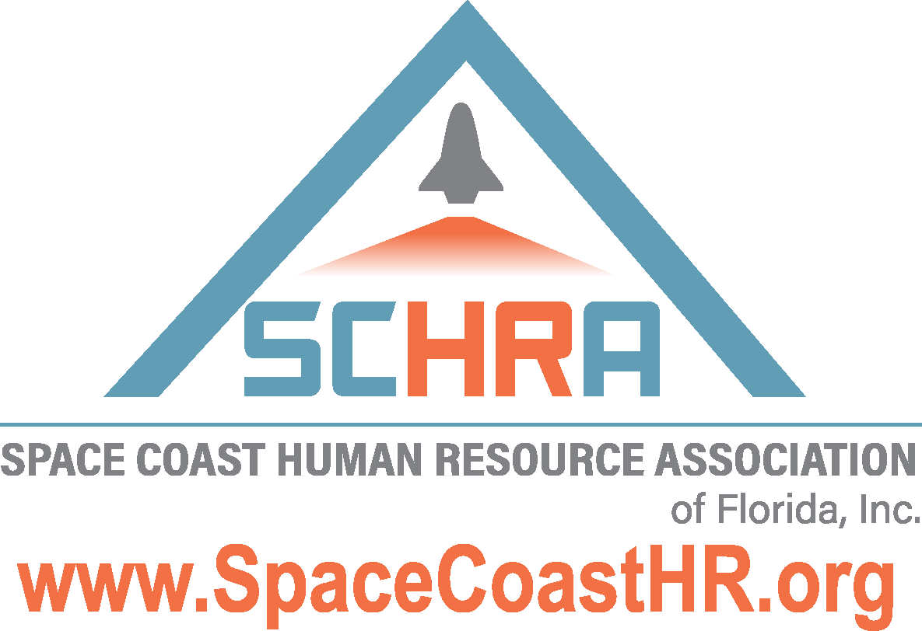
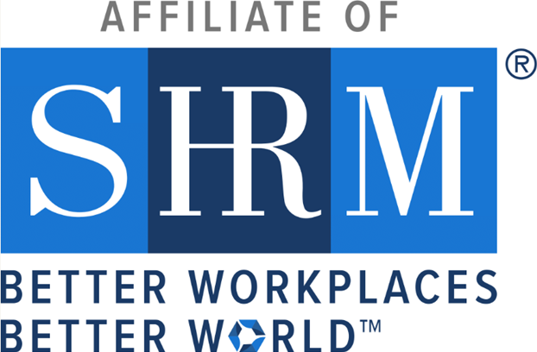

Space Coast Human Resource Association Honored for Elevating HR and Enhancing Workplaces
Receives SHRM’s Prestigious 2024 Platinum Excel Award

Melbourne, FL — May 23, 2024 — SHRM has awarded the 2024 Platinum Excel Award to the Space Coast Human Resource Association in recognition of its exceptional work and accomplishments in 2024. This award celebrates the Chapter’s strategic initiatives, innovative programming, and unwavering commitment to elevating the HR profession and improving workplaces across the region.

The Excel Award—given at the Bronze, Silver, Gold, and Platinum levels—is a symbol of excellence in chapter and state council leadership. Honorees are recognized for activities that align with SHRM’s mission to empower people and workplaces by advancing human resource practices and maximizing human potential.

“SHRM’s impact on the world of work is made possible by the dedication and leadership of our chapters and state councils,” said Johnny C. Taylor, Jr., SHRM-SCP, president and chief executive officer of SHRM. “The Platinum Excel Award is not only a celebration of the great work done by the Space Coast Human Resource Association — it’s recognition of their focus, innovation, and determination to create better workplaces. Their HR leadership is truly exemplary.”

The Space Coast Human Resource Association will receive national recognition through SHRM publications and events, an official award logo for use in communications, and tools to help share this achievement with its members and community.

In 2024, the Space Coast Human Resource Association led several impactful initiatives, including the annual Space Coast HR Conference, annual Legal Conference, community support to seniors and veterans, supporting the growth and success of HR professionals and organizations across Brevard County and Florida.

For more information about the Space Coast Human Resource Association, visit SpaceCoastHR.org.

